Android Intent Tutorial

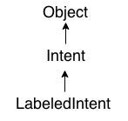

**Android Intent** is the *message* that is passed between components such as activities, content providers, broadcast receivers, services etc.

It is generally used with startActivity() method to invoke activity, broadcast receivers etc.

The **dictionary meaning** of intent is *intention or purpose*. So, it can be described as the intention to do action.

The LabeledIntent is the subclass of android.content.Intent class.

Android intents are mainly used to:

* Start the service
* Launch an activity
* Display a web page
* Display a list of contacts
* Broadcast a message
* Dial a phone call etc.

Types of Android Intents

There are two types of intents in android: implicit and explicit.

1) Implicit Intent

**Implicit Intent** doesn't specifiy the component. In such case, intent provides information of available components provided by the system that is to be invoked.

For example, you may write the following code to view the webpage.

1. Intent intent=**new** Intent(Intent.ACTION_VIEW);

intent.setData(Uri.parse("http://www.javatpoint.com"));

startActivity(intent);

2) Explicit Intent

**Explicit Intent** specifies the component. In such case, intent provides the external class to be invoked.

Intent i = **new** Intent(getApplicationContext(), ActivityTwo.**class**);

startActivity(i);

To get the full code of explicit intent, visit the next page.

Android Implicit Intent Example

Let's see the simple example of implicit intent that displays a web page.

**activity_main.xml**

*File: activity_main.xml*

**<RelativeLayout** xmlns:androclass="http://schemas.android.com/apk/res/android"

    xmlns:tools="http://schemas.android.com/tools"

    android:layout_width="match_parent"

    android:layout_height="match_parent"

    tools:context=".MainActivity" **>**

**<EditText**

        android:id="@+id/editText1"

        android:layout_width="wrap_content"

        android:layout_height="wrap_content"

        android:layout_alignParentTop="true"

        android:layout_centerHorizontal="true"

        android:layout_marginTop="44dp"

        android:ems="10" **/>**

**<Button**

        android:id="@+id/button1"

        android:layout_width="wrap_content"

        android:layout_height="wrap_content"

        android:layout_below="@+id/editText1"

        android:layout_centerHorizontal="true"

        android:layout_marginTop="54dp"

        android:text="Visit" **/>**

**</RelativeLayout>**

**Activity class**

*File: MainActivity.java*

**package** org.sssit.implicitintent;

**import** android.net.Uri;

**import** android.os.Bundle;

**import** android.app.Activity;

**import** android.content.Intent;

**import** android.view.View;

**import** android.view.View.OnClickListener;

**import** android.widget.Button;

**import** android.widget.EditText;

**public** **class** MainActivity **extends** Activity {

    @Override

**protected** **void** onCreate(Bundle savedInstanceState) {

**super**.onCreate(savedInstanceState);

        setContentView(R.layout.activity_main);

**final** EditText editText1=(EditText)findViewById(R.id.editText1);

        Button button1=(Button)findViewById(R.id.button1);

        button1.setOnClickListener(**new** OnClickListener() {

            @Override

**public** **void** onClick(View arg0) {

                String url=editText1.getText().toString();

                Intent intent=**new** Intent(Intent.ACTION_VIEW,Uri.parse(url));

                startActivity(intent);

            }

        });

    }

}

**Output:**

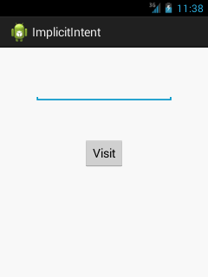 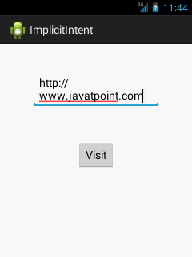

Prepared By: Prof. Kamlesh A. Meshram